**Lecture: Gathering Facts**

We have touched on gathering facts during our playbook, learn what that is and how we can use it to explore our node settings.

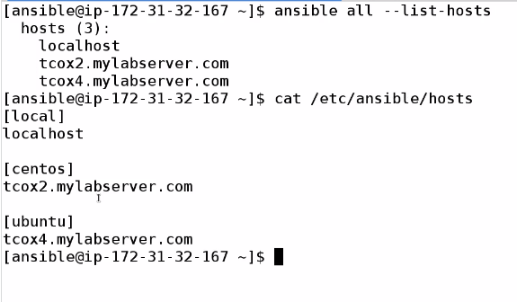

Performing gathering fact :

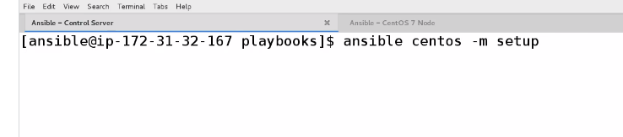

Give output a ton of information

For particular information we can use filter

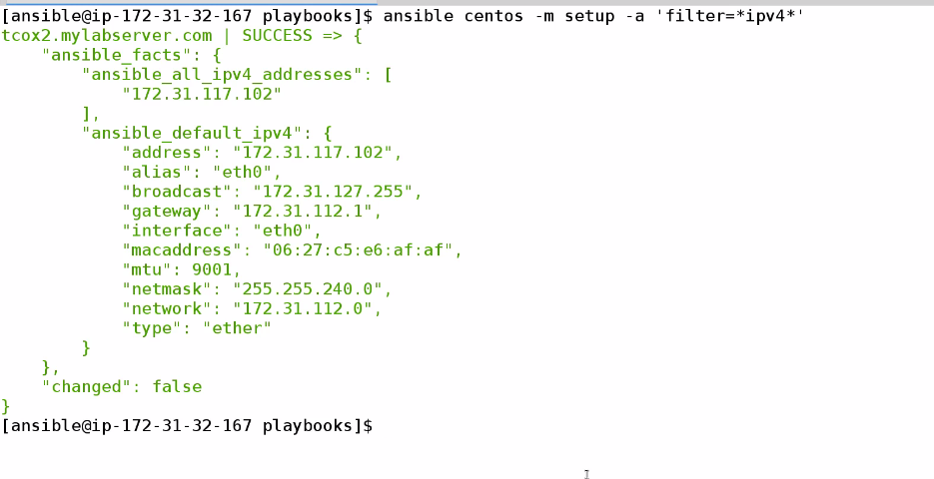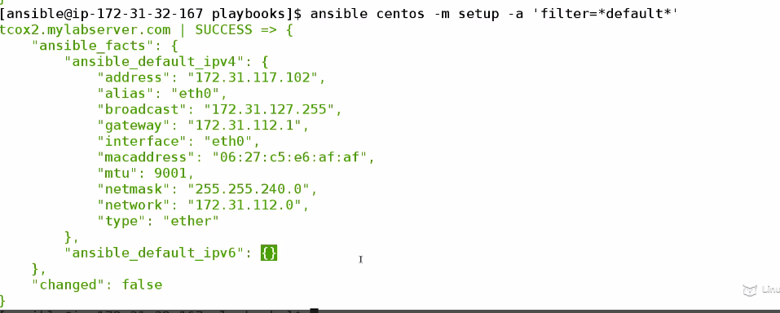

Create a local file



Here is the created directory (for all particular host)

